# 

**PROJECT REPORT ON**

**Notice Board Management System**

**Submitted By:**

Sai Subham Pattnaik (19cse104)

Kumar Samarjeet (19cse111)

Mayank Gupta (19sce115)

***29*th June 2021**



***GANDHI INSTITUTE OF ENGINEERING AND TECHNOLOGY UNIVERSITY***

***GUNUPUR, RAYAGADA***

# *PIN-765022, ODISHA, INDIA*

# CERTIFICATE

This is to certify that SaiSubham Pattnaik (Roll No. 19CSE104),Kumar Samarjeet(Roll No. 19CSE111) And Mayank Gupta (Roll No. 19CSE115)

have successfully completed the project titled **“Notice Board Management System”** at Academy Of Technology in the fulfillment of requirements of Fourth Semester, **Bachelor of Technology (Computer Science & Engineering)** of GIET University,Gunupur.

**ACKNOWLEDGEMENT**

We deem it a pleasure to acknowledge our sense of gratitude to our project guide under whom we have carried out the project work. His incisive and objective guidance and timely advice encouraged us with constant flow of energy to continue thework.

We wish to reciprocate in full measure the kindness shown by Mr. SANJAY KUMAR KUANAR (H.O.D, Computer Science and Engineering) who inspired us with his valuable suggestions in successfully completing the project work.

We shall remain grateful to Co-ordinator, for providing us a strong academic atmosphere by enforcing strict discipline to do the project work with utmost concentration and dedication.

Finally, we must say that no height is ever achieved without some sacrifices made at some end and it is here where we owe our special debt to our parents and our friends for showing their generous love and care throughout the entire period of time.

Date: 29.06.2021 Sai Subham Pattnaik (Roll No. 19CSE104)

Place: GUNUPUR,RAYAGADA Kumar Samarjeet (Roll No.19cse111)

Odisha Mayank Gupta (Roll No.19sce115)

**ABSTRACT**

This project is aimed to developing an online Notice Board Management System. The entire project has been developed keeping in view of the distributed client server computing technology, in mind. This project would help the head of the institution to ease the method of circulation of notice. It is a common portal where the message would be reaching to everyone under that institution on time.

The project has been planned to be having the view of distributed architecture, with centralized storage of the database. The application for the storage of the data has been planned. The database connectivity is planned using the “SQL Connection” methodology.

The entire project has been developed keeping in view of the distributed client server computing technology, in mind. The user interfaces are browser specific to give distributed accessibility for the overall system. The internal database has been selected as Xampp Server.

Contents

|  |  |  |
| --- | --- | --- |
| **Sl. No.** | **Topics** | **Page no.** |
| 1. | Introduction | 6 |
| 2. | Intended Audience | 6 |
| 3. | Scope | 6 |
| 4. | Software Requirement | 6 |
| 5. | Proposed System/Project Plan | 7 |
| 6. | Future Updates | 8 |
| 7. | Benifits of Our Application | 9 |
| 8. | Design Strategy | 9 |
| 9. | Screenshots | 9-11 |
| 10. | Screenshot of codes | 11-13 |
| 11. | Conclusion | 13 |
| 12. | References | 13 |

# Introduction

## Purpose of this document

The purpose of this document is to show results and outcomes of this project. This document is a part of series of documents and its purpose is to consolidate all of them and present an overview of the whole project.

## Intended Audience

The intended audiences for this document are:

* HODs
* Faculties
* Students

## Scope

* The Notice Board Management System is developed to keep records of the notices. The primary objective of our project is to eliminate the chaos and confusion created during circulation of the notice in the institution at different levels. For example, the head of the institution wants to circulate a certain message only to HODs of all department. There are chances that message may leak to someone else but in this portal, if the head of the institution wants to send the message to HODs only, then his message will be posted on the HODs’ dashboard only and will not be shared to other faculties or students.

The technology platform in implementing this system by using MySQL for SQL database and HTML5, CSS and JavaScript for web development. Simultaneously, We have developed a web application for both customers and also or admin so that any customers can give their orders with their fingertips. Also, the admin can remotely manage their customers from the application itself.

.

**Software Requirement For Website**

* Server - Apache 2.4.29
* Backend Language - PHP 7.2.1
* DB - MySQL
* Frontend - HTML5, CSS, JAVA SCRIPT
* Control Panel - XAMPP 7.2.1
* Editor - Sublime Text
* Browser- Google Chrome

**Software/Hardware Requirement For Webapplication**

* Android Mobile set With minimum of android version 6.1
* GIETU_NOTICE.apk for all to access our services

**HTML**

HTML describes the structure of a [web page](https://en.wikipedia.org/wiki/Web_page) [semantically](https://en.wikipedia.org/wiki/Semantic_Web) and originally included cues for the appearance of the document.

[HTML elements](https://en.wikipedia.org/wiki/HTML_element) are the building blocks of HTML pages. With HTML constructs, [images](https://en.wikipedia.org/wiki/HTML_element#Images_and_objects) and other objects such as [interactive forms](https://en.wikipedia.org/wiki/Fieldset) may be embedded into the rendered page. HTML provides a means to create [structured documents](https://en.wikipedia.org/wiki/Structured_document) by denoting structural [semantics](https://en.wikipedia.org/wiki/Semantics) for text such as headings, paragraphs, lists, [links](https://en.wikipedia.org/wiki/Hyperlink), quotes and other items. HTML elements are delineated by *tags*, written using [angle brackets](https://en.wikipedia.org/wiki/Bracket#Angle_brackets). Tags such as <**img** /> and <**input** /> directly introduce content into the page. Other tags such as <**p**> surround and provide information about document text and may include other tags as sub-elements. Browsers do not display the HTML tags, but use them to interpret the content of the page.

HTML can embed programs written in a [scripting language](https://en.wikipedia.org/wiki/Scripting_language) such as [JavaScript](https://en.wikipedia.org/wiki/JavaScript), which affects the behavior and content of web pages.

**CSS**

CSS is designed to enable the separation of presentation and content, including [layout](https://en.wikipedia.org/wiki/Page_layout), [colors](https://en.wikipedia.org/wiki/Color), and [fonts](https://en.wikipedia.org/wiki/Typeface).[[3]](https://en.wikipedia.org/wiki/Cascading_Style_Sheets#cite_note-3) This separation can improve content [accessibility](https://en.wikipedia.org/wiki/Accessibility), provide more flexibility and control in the specification of presentation characteristics, enable multiple [web pages](https://en.wikipedia.org/wiki/Web_page) to share formatting by specifying the relevant CSS in a separate .css file which reduces complexity and repetition in the structural content as well as enabling the .css file to be [cached](https://en.wikipedia.org/wiki/Cached) to improve the page load speed between the pages that share the file and its formatting.

**PHP**

PHP code is usually processed on a [web server](https://en.wikipedia.org/wiki/Web_server) by a PHP [interpreter](https://en.wikipedia.org/wiki/Interpreter_(computing)) implemented as a [module](https://en.wikipedia.org/wiki/Plugin_(computing)), a [daemon](https://en.wikipedia.org/wiki/Daemon_(computing)) or as a [Common Gateway Interface](https://en.wikipedia.org/wiki/Common_Gateway_Interface) (CGI) executable. On a web server, the result of the interpreted and executed PHP code – which may be any type of data, such as generated [HTML](https://en.wikipedia.org/wiki/HTML) or binary image data – would form the whole or part of a [HTTP](https://en.wikipedia.org/wiki/Hypertext_Transfer_Protocol) response. Various [web template systems](https://en.wikipedia.org/wiki/Web_template_system), web [content management systems](https://en.wikipedia.org/wiki/Content_management_system), and [web frameworks](https://en.wikipedia.org/wiki/Web_framework) exist which can be employed to orchestrate or facilitate the generation of that response. Additionally, PHP can be used for many programming tasks outside of the web context, such as standalone [graphical applications](https://en.wikipedia.org/wiki/Graphical_user_interface)[[10]](https://en.wikipedia.org/wiki/PHP#cite_note-10) and robotic [drone](https://en.wikipedia.org/wiki/Unmanned_aerial_vehicle) control.[[11]](https://en.wikipedia.org/wiki/PHP#cite_note-11) Arbitrary PHP code can also be interpreted and executed via [command-line interface](https://en.wikipedia.org/wiki/Command-line_interface) (CLI).

**XAMPP**

XAMPP is a [free and open-source](https://en.wikipedia.org/wiki/Free_and_open-source) [cross-platform](https://en.wikipedia.org/wiki/Cross-platform) [web server](https://en.wikipedia.org/wiki/Web_server) [solution stack](https://en.wikipedia.org/wiki/Solution_stack) package developed by Apache Friends, consisting mainly of the [Apache HTTP Server](https://en.wikipedia.org/wiki/Apache_HTTP_Server), [MariaDB](https://en.wikipedia.org/wiki/MariaDB) [database](https://en.wikipedia.org/wiki/Database), and [interpreters](https://en.wikipedia.org/wiki/Interpreter_(computing)) for scripts written in the [PHP](https://en.wikipedia.org/wiki/PHP) and [Perl](https://en.wikipedia.org/wiki/Perl) [programming languages](https://en.wikipedia.org/wiki/Programming_language). Since most actual web server deployments use the same components as XAMPP, it makes transitioning from a local test server to a live server possible.

**Sublime Text Editor**

SublimeText is a [shareware](https://en.wikipedia.org/wiki/Shareware) [cross-platform](https://en.wikipedia.org/wiki/Cross-platform) [source code editor](https://en.wikipedia.org/wiki/Source_code_editor) with a [Python](https://en.wikipedia.org/wiki/Python_(programming_language)) [application programming interface](https://en.wikipedia.org/wiki/Application_programming_interface) (API). It natively supports many [programming languages](https://en.wikipedia.org/wiki/Programming_languages) and [markup languages](https://en.wikipedia.org/wiki/Markup_languages), and functions can be added by users with [plugins](https://en.wikipedia.org/wiki/Plugins), typically community-built and maintained under [free-software licenses](https://en.wikipedia.org/wiki/Free_software_licenses).

**Web Browser**

The primary function of a web browser is to render [HTML](https://techterms.com/definition/html), the code used to design or "mark up" [webpages](https://techterms.com/definition/webpage). Each time a browser loads a web page, it processes the HTML, which may include text, [links](https://techterms.com/definition/link), and references to images and other items, such as [cascading style sheets](https://techterms.com/definition/css) and [JavaScript](https://techterms.com/definition/javascript) functions. The browser processes these items, then renders them in the browser window.

**Proposed System/Project Plan:**

**Registrar Pannel**:

The Registrar can see all the notices. He can add notices to desired reciever.

The options given to registrar are:·

* View all notices
* Change Password
* Add new notice
* Delete Notice
* Logout

**HOD Pannel**:

Each HOD is given an unique user id and password, which identifies him uniquely. The member is given a login form. he enters the login details user id and password. .

The options given to HOD are:·

* View notices
* Logout

**Faculty Pannel**:

Each faculty is given an unique user id and password, which identifies him uniquely. The member is given a login form. he enters the login details user id and password. .

The options given to admin are:·

* View notices
* Logout

**Student Pannel**:

Each Student is given an unique user id and password, which identifies him uniquely. The member is given a login form. he enters the login details user id and password. .

The options given to student are:·

* View notices
* Logout

**Future updates:-**

* Further updates will also have a password changing option for HOD,Faculties and Students
* HOD can also post notices for Branch Students.
* Class teacher and Proctor Pannel
* Student can ask queries regarding notice and anyone from management can reply them.
* New Layout for more user-friendly and responsive environment.
* Registrar/HODs/Faculties can send notice to any set of students/branch/ a particular batch/section.
* Flash notification for new notices.

**Benifits of web-application:**

1. Anyone can access and see notices at any moment.

2. For some urgent meetings the higher authorities can call for an meeting through this system.

**Design Strategy**

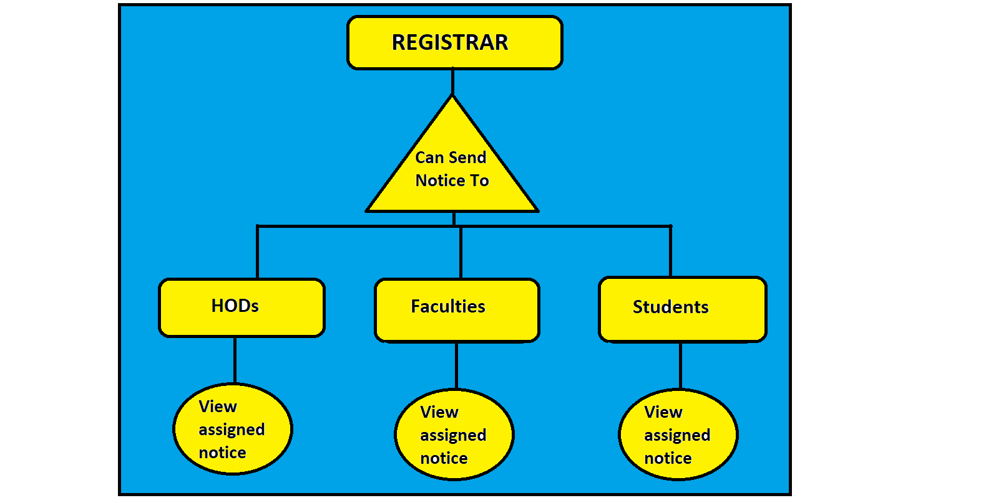

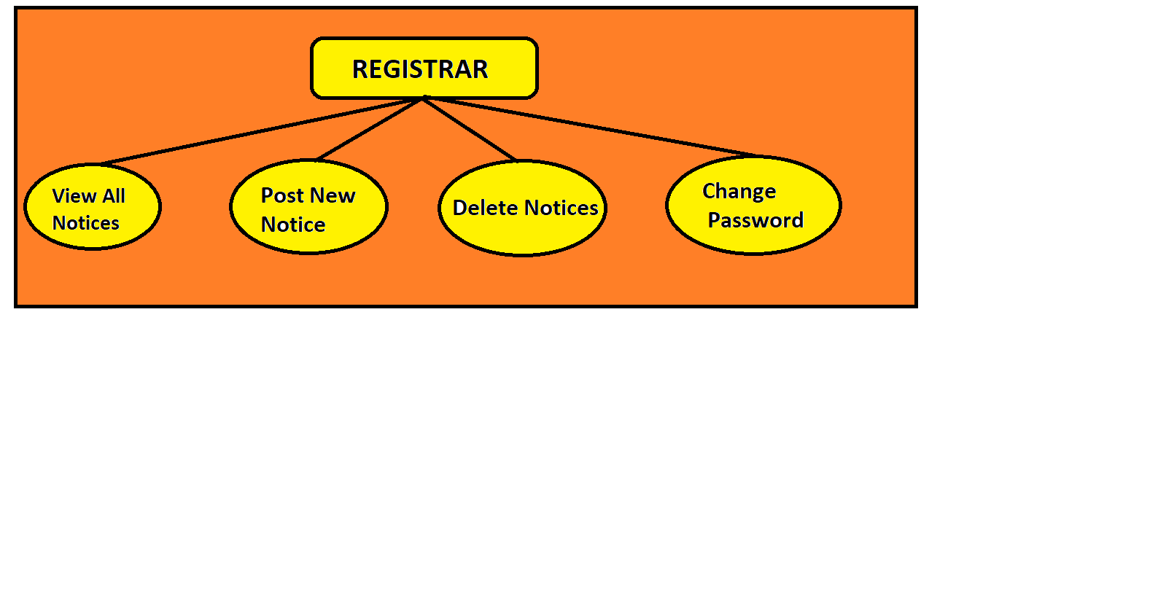

**Screenshots :-**

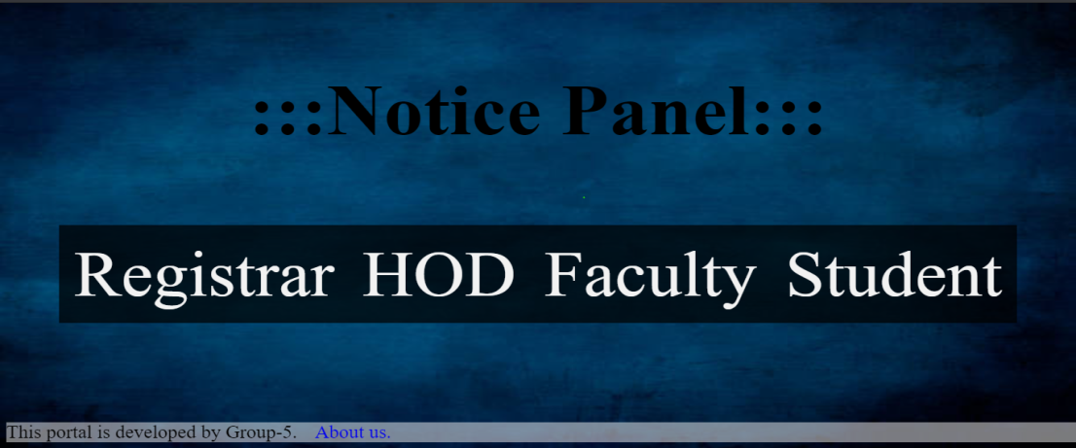 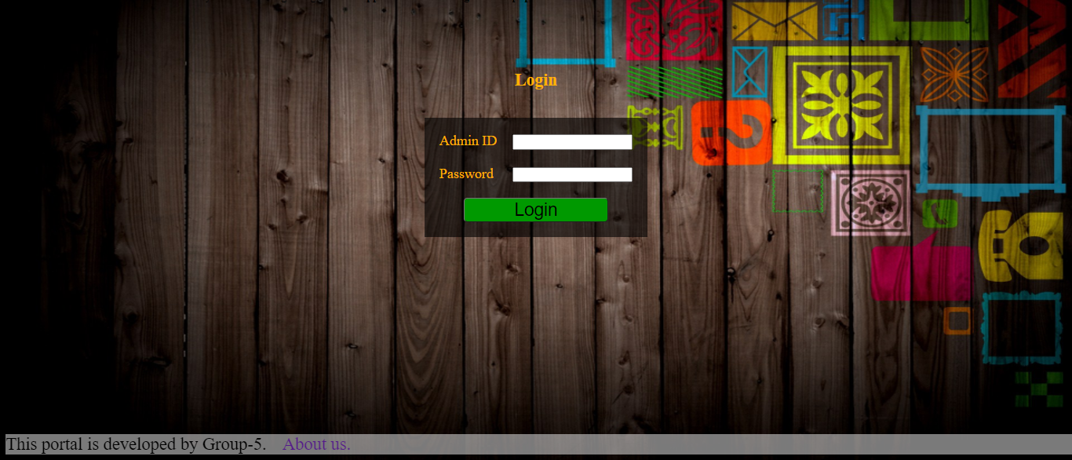

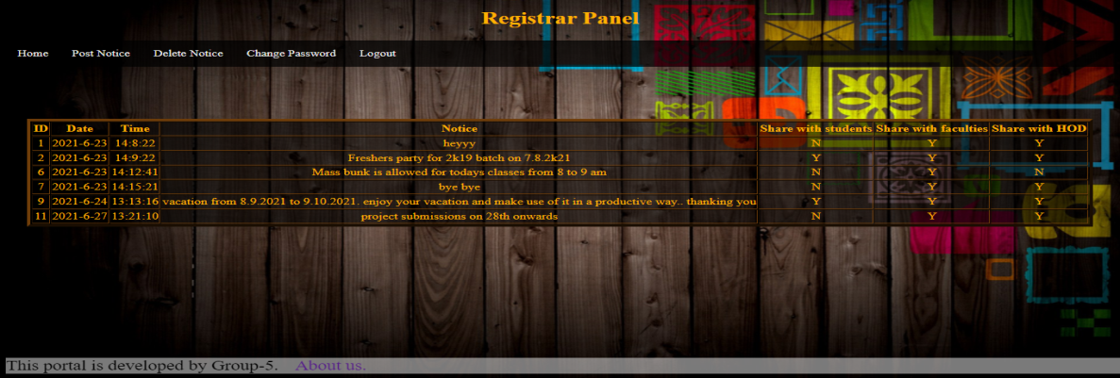

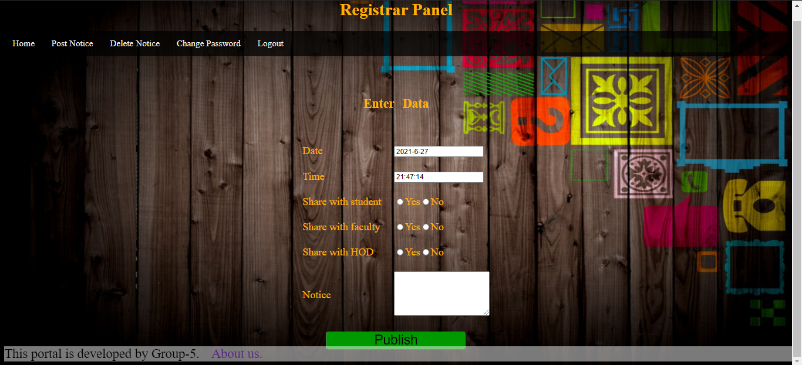

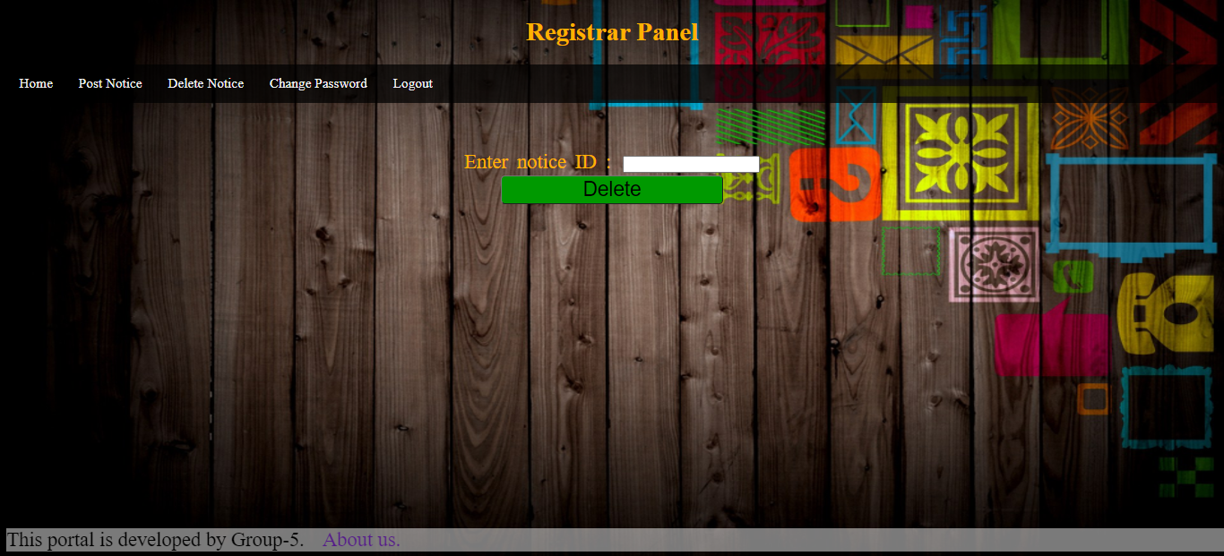 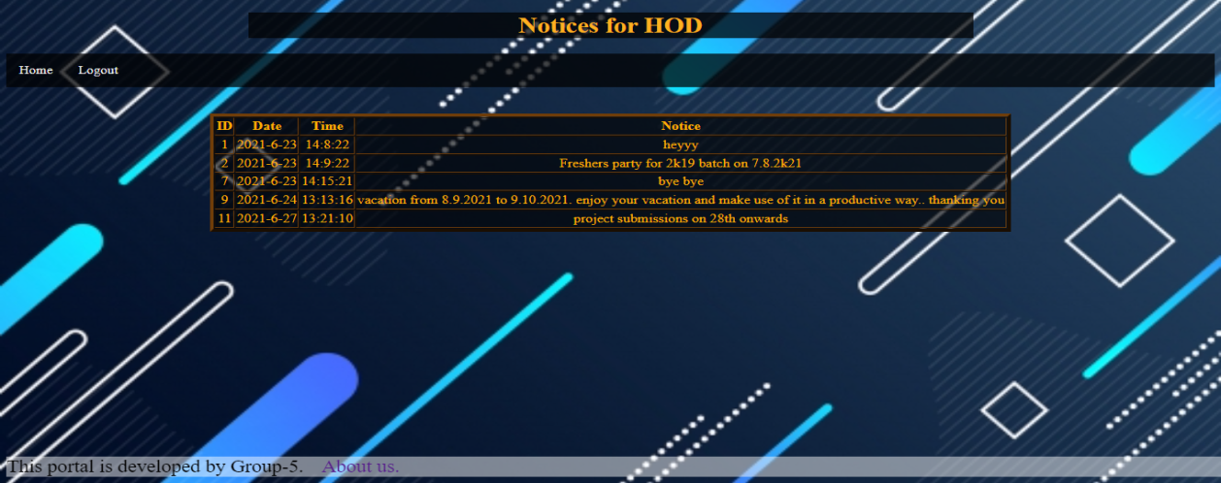

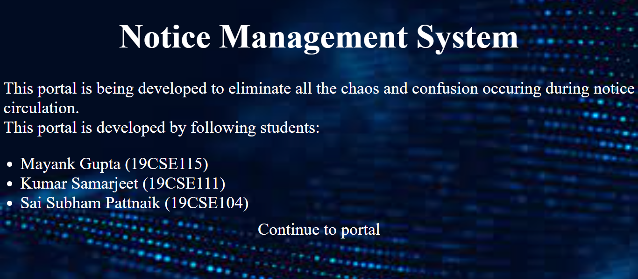

**Screenshot of codes:**

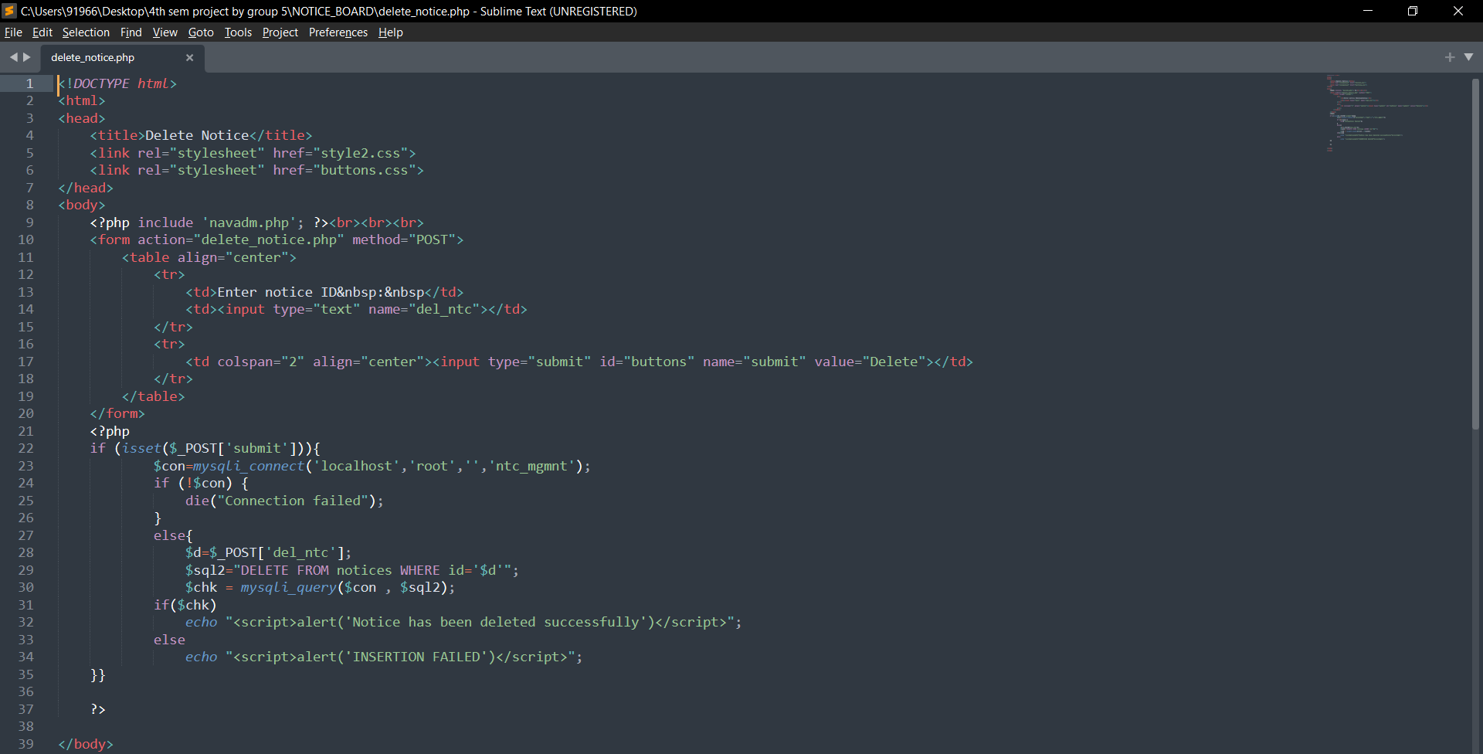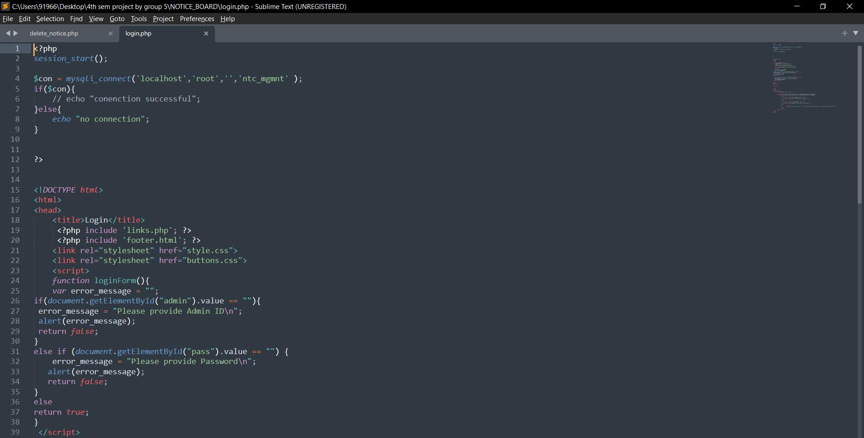

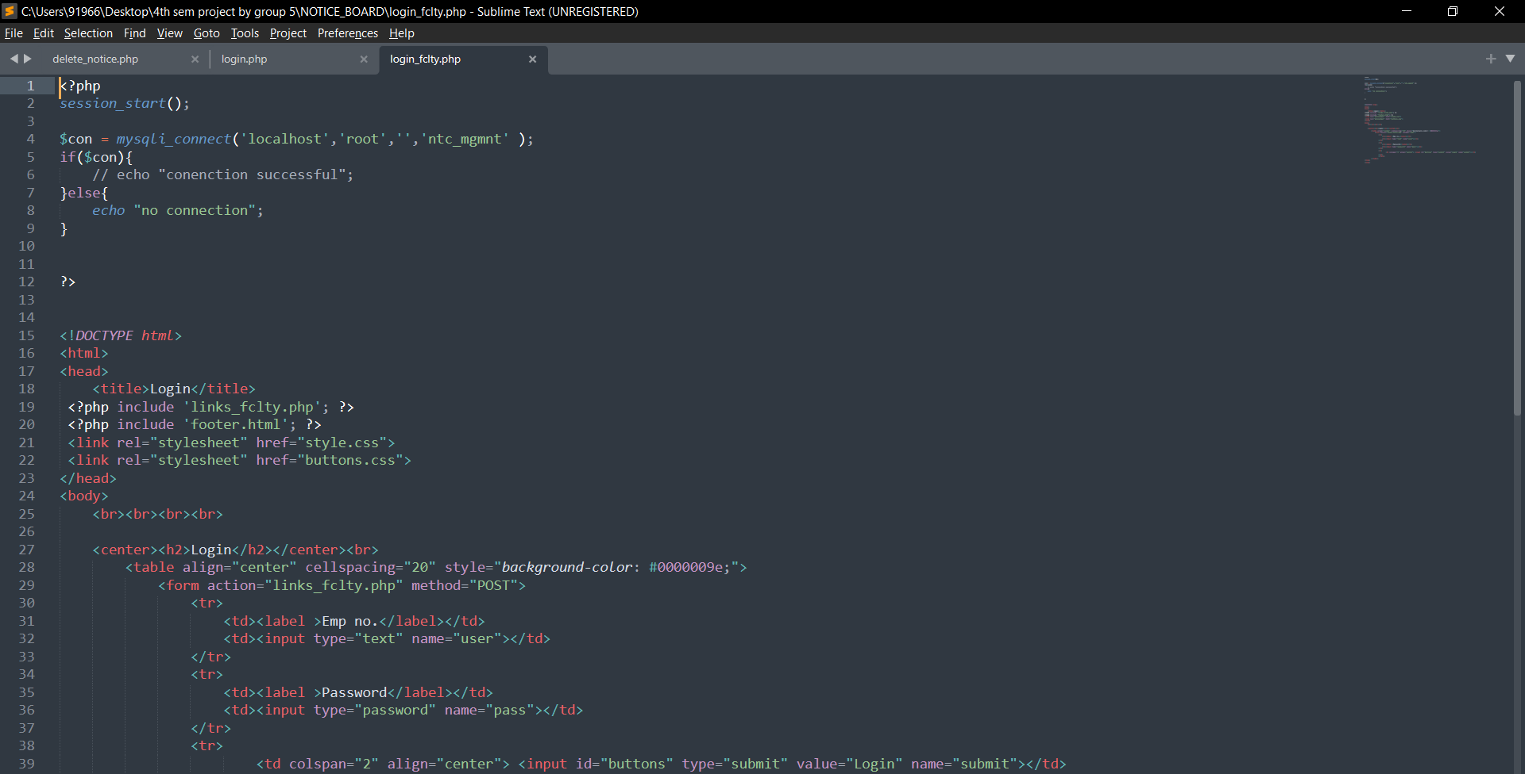

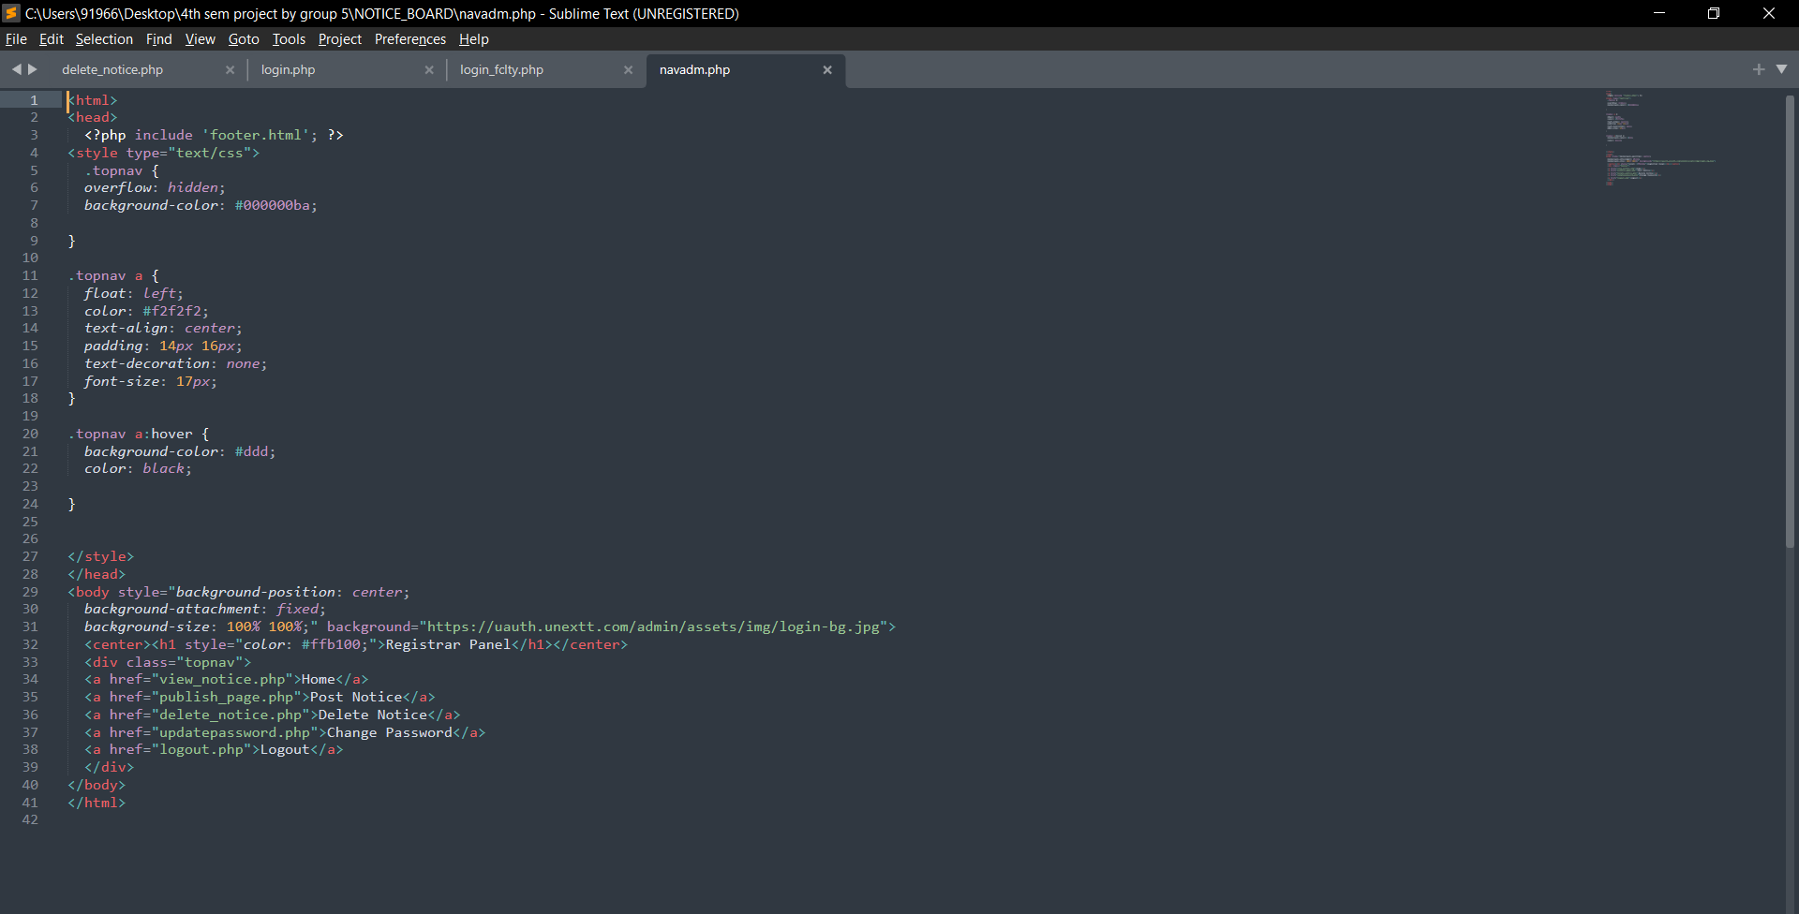

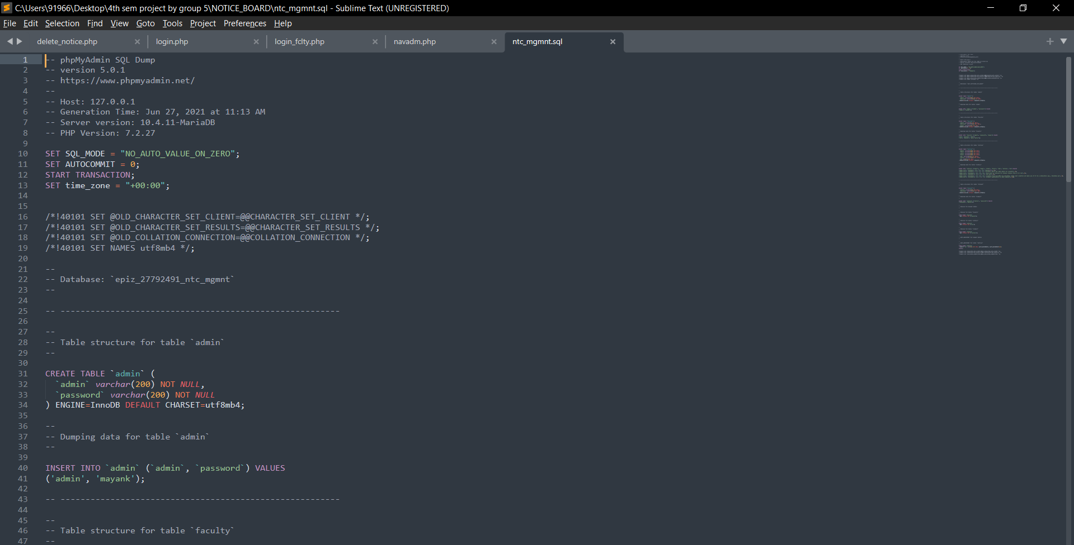

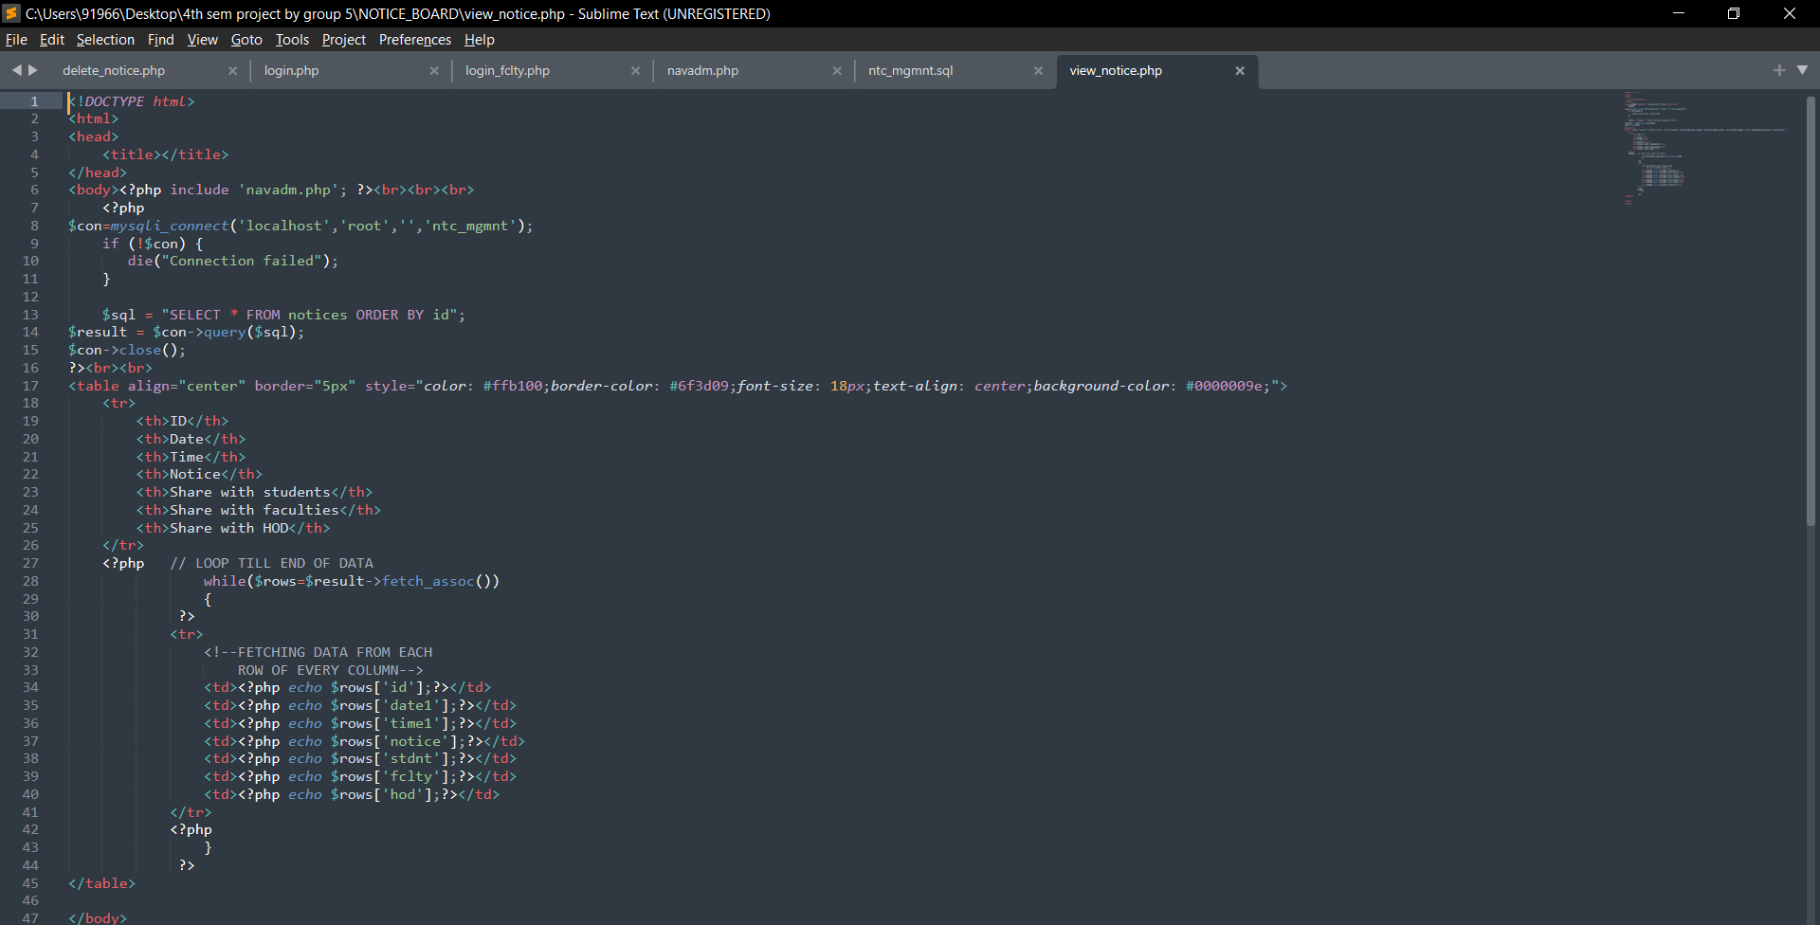

**Conclusion:**

This is a simple and user friendly web application that would be helpful for the head of the institution to ease the method of circulation of notice. It is a common portal where the message would be reaching to everyone under that institution on time.

This project has also let us learn a lot about the various tools that are useful and helpful for the webpage development and management.

**References:**

**1.**There will be specific aspects of our project report that only our supervisor can advise us on so it is important that you discuss an outline of the project report with our supervisor before you begin to write up.

**2.www.w3schools.com**

**3.www.google.com**

**4.www.youtube.com**

|  |  |  |
| --- | --- | --- |
| **ROLL NUMBER** | **NAME** | **EMAIL ID** |
| **19CSE104** | **SAI SUBHAM PATTNAIK** | [19cse104.saisubhampattnaik@giet.edu](mailto:19cse104.saisubhampattnaik@gie.edu) |
| **19CSE111** | **KUMAR SAMARJEET** | [19cse111.kumarsamarjeet@giet.edu](mailto:19cse111.kumarsamarjeet@giet.edu) |
| **19CSE115** | **MAYANK GUPTA** | [19cse115.mayankgupta@giet.edu](mailto:19cse115.mayankgupta@giet.edu) |